Making a reverse Proxy!

Assuming docker + docker-compose is installed:

1 – Create the folder that will contain the project

2 – Create the docker-compose.yml file

3- Create the files for the apps (In this case I use the same requirements.txt and change a text in the main.py file, statics folder is just a placeholder)

4 – Set up the file with NGINX + apps that you want the proxy to connect (In my case I set up 2 fastAPI apps)

5 – Create the nginx.conf file, this will point to the FastAPI apps and the main site on port 80

6 – Run: sudo docker-compose up -d

7 – Working!

Pictures:

Docker-compose up –d running in vps

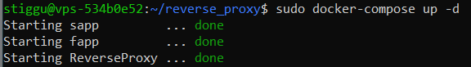

Main website on port 80

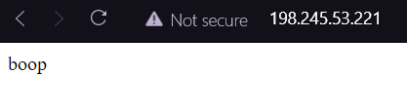

First FastAPI app:

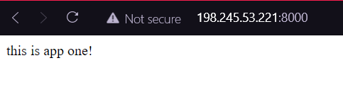

Second FastAPI app:

